Additional Questions to Consider

(to be taken up in lectures)

**Chapter 1**

1. Are the following statements normative or positive?

I. Rent on student housing is too high.

II. Christmas Day falls on October 31.

III. Society is better off with free medical care.

2. Which of the following is NOT a factor of production:

A tropical plant

Timber

Coal

Solar energy

High-skilled labour

Low-skilled labour

Physical capital

Financial assets

Entrepreneurship

**Chapter 2**

3. What is the opportunity cost of increasing X by one unit starting at point A? What if resources become misallocated in increasing X by one unit?

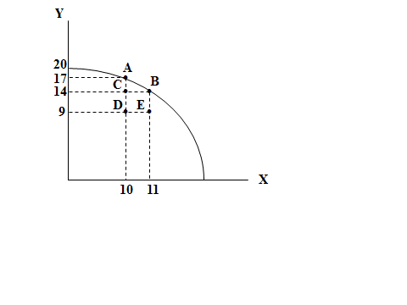

**Chapter 3**

4. Demand curve: P=80-Q

Supply curve: P=10+0.75Q

What is the market equilibrium quantity and price?

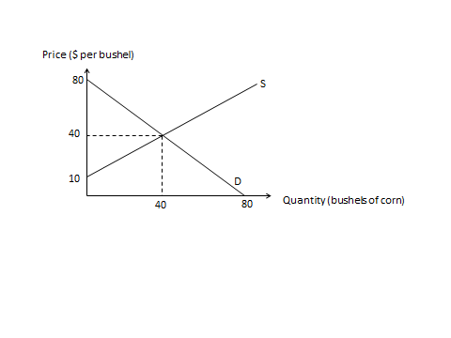

5. Does the following event represent a movement along the demand curve or a shift of the demand curve?

People buy more roses the week of Valentine’s Day even though prices are higher than at other times of the year.

6. Do the following events represent a movement along the supply curve or a shift of the supply curve?

Apple farmers supply more apples to market during harvest season even though prices are lower than at other times of the year.

More beachfront cottage owners put their cottages up for rent during the summer months when there is an increase in demand.

7. Explain the process of why the equilibrium price of vegetables would rise during a shortage and how during the process of rising, the shortage would decrease.

**Chapter 4**

8. What does the following situation imply about the price elasticity of demand?

A decrease in supply causes *consumer spending* to decrease.

**Chapter 5**

9. Demand curve: P=80-Q

Supply curve: P=10+0.75Q

D=S gives Q*=40

What is DWL when Q=20?

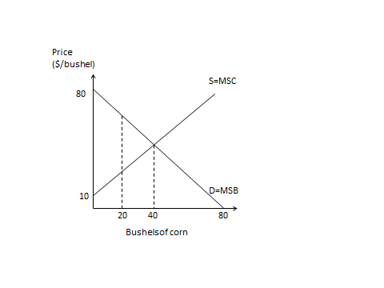

**Chapter 6**

10. Identify the truthfulness of the following statements:

I. A price ceiling set at $6 per unit will result in excess

supply.

II. A price floor set at $2 per unit will result in a deadweight loss.

III. A production quota set at 50 units will cause the market

equilibrium price to fall to $2 per unit.

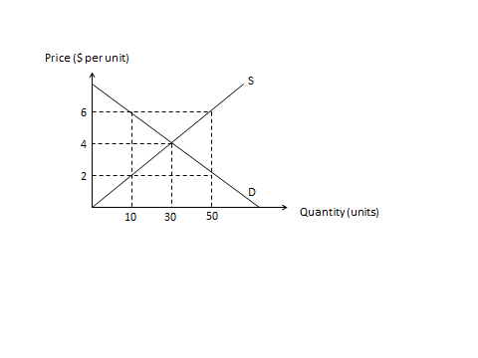

11. If a **binding** rent ceiling is set at $2 per unit of housing, which of the following statements will be correct?

I. All consumers will be worse off.

II. All producers will be worse off.

III. Surplus will be transferred from landlords to tenants.

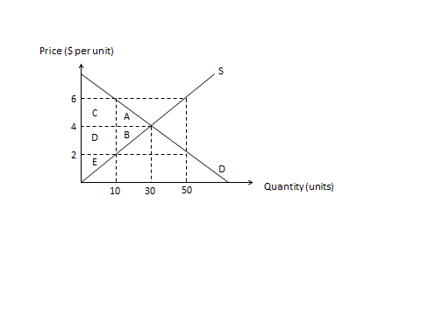

**Chapter 9**

12. Suppose X is on the horizontal axis and Z on the vertical axis. Suppose the price of Z is $4, and the price of X is originally $2 but increases to $8. What is the opportunity cost of a unit of X at the original set of prices? What is the opportunity cost of a unit of X at the new set of prices?

13. Suppose an individual buys two goods: smoothies (x-axis) and sugary drinks (y-axis). Suppose that at the individual’s current consumption choice MRS=8 and the relative price of a smoothie is 4. Use an indifference curve to ***explain*** ***why*** the individual will be better off buying more smoothies and less sugary drinks.

Suppose instead that at the individual’s current consumption choice MRS=6 and the relative price of a smoothie is 4. Use an indifference curve to ***explain*** ***why*** the individual will be better off buying more sugary drinks and less smoothies.

14. Suppose an individual has the following preferences:

Sam likes his coffees to contain exactly 2 sugars with every 1 cup of coffee. If units of sugar is on the vertical axis and cups of coffee are on the horizontal axis, what will Sam’s indifference curves look like?

Ben likes both coke and strong coffee and is always willing to substitute 2 cans of cokes for 1 strong cup of coffee. If cans of coke are on the vertical axis and cups of coffee on the horizontal axis, what will Ben’s indifference curves look like?

**Chapter 10**

15. If MPL>0 but MP↓ as L↑, then identify the truthfulness of the following statements:

1. TPmust be falling.

2. APL must be falling.

16. Which of the following are technically efficient methods of producing 75 units of output?

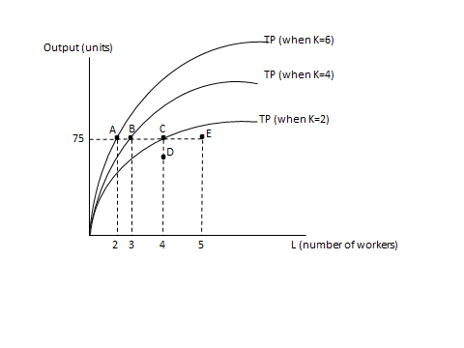

17. In the long run, the firm ***can*** operate on which of the following short run cost curves?

In the long run, the firm ***will*** operate on which of the following short run cost curves?

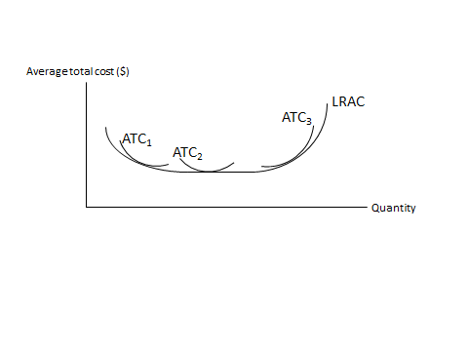

18. Suppose a firm is using L=10, K=10 to produce Q=10. Now it doubles both L and K resulting in ***20 more*** units of output being produced. The firm is experiencing

A. constant returns to scale

B. economies of scale

C. diseconomies of scale